Grade 7 Accelerated · Unit 4 · Lessons 2–3  Multiplying and Dividing in Scientific Notation  Independent Set 4.02 ANSWER KEY | Name  Date  Period

Six questions, on your own, in silence. Show the step that does the work.
1. 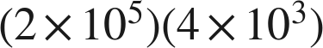


2. 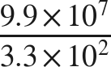


3. 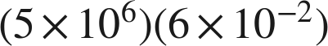
The product is , which is not finished.

4. 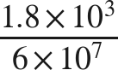
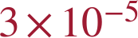
The quotient is 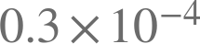, which is not finished either.

5. 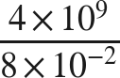

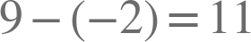, and  is not finished.

6. Find .
n = 6
.

